***Accounting & Financial Analytics Assignment – 4***

***Task – 1: Stock Market Analysis***

***Title: Analyzing the Performance***

***Content:***

1. ***Introduction.***
2. ***Historical Stock Price Data.***
3. ***Key Metrix.***
4. ***Compare Performance to Relevant Index.***
5. ***Significant Events.***
6. ***Conclusion.***

***Introduction***

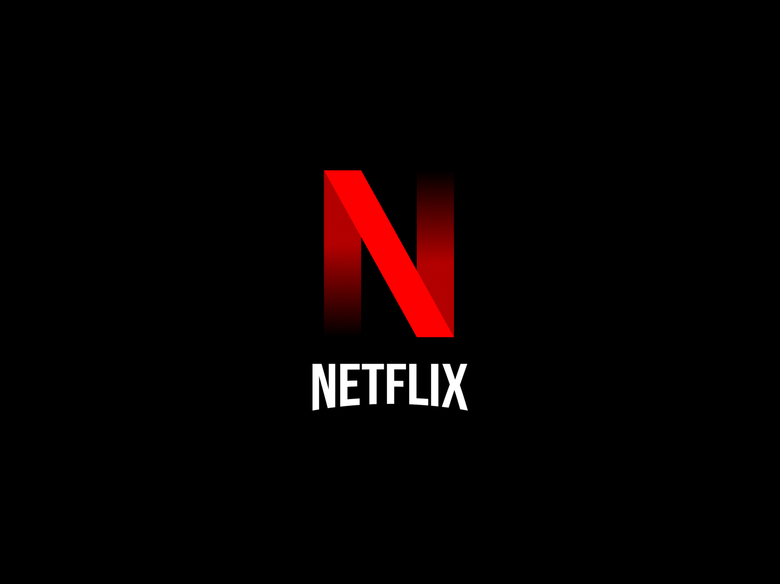

**Netflix is an American subscription video on-demand over-the-top (OTT) streaming service. The service primarily distributes original and acquired films and television shows from various genres, and it is available internationally in multiple languages.**

**Headquarters – Los Gatos, California, U.S, Country of origin – United States, Industry – Entertainment mass media, Users - ▲260.28 million (as of January 23, 2024).**

***Netflix* launched on January 16, 2007, nearly a decade after Netflix, Inc. began its pioneering DVD-by-mail movie rental services, Netflix is the most-subscribed video on demand streaming media services. In more than 190 countries as of January 2024. By 2022, “Netflix Original” products accounted for half of its library in the United States and the namesake company had ventured into other categories, such as video game publishing of mobile games via flagship service. As of October 2023, Netflix is the 24th most-visited website in the world.**

**“Netflix Originals” are content that is produced, that is produced, co-produced, or distributed exclusively by Netflix funds its original shows differently than other TV networks when they sign a project, providing the money upfront and ordering two seasons of most series. Its keep licensing rights, which normally give production companies future revenue opportunities from syndication, merchandising, etc.**

**In Netflix you can also download TV shows and movies to your iOS, Android, or Windows 10 device and watch without an internet connection. Netflix has exclusive pay TV deals with several studios. The deals give Netflix exclusive streaming rights while adhering to the structures of traditional pay TV term**s.

***Netflix India:***

**Netflix India is an Indian subsidiary of the American global internet streaming on-demand media provider Netflix** **that distributes a number of contents called "originals" (films, series, miniseries, etc.) along with acquired content. It was launched in January 2016.**

**Netflix is a streaming service that offers a wide variety of award-winning TV shows, movies, anime, documentaries, and more on thousands of internet-connected devices. You can watch as much as you want, whenever you want – all for one low monthly price.**



***Historical Stock Price Data***

**Historical stock price data of Netflix specifically refers to a chronological record of past trading prices for Netflix, Inc. (ticker symbol: NFLX) shares on various financial markets where it is listed, such as the Yahoo Finance. This data typically includes the opening price, closing price, highest price (high), lowest price (low), and volume of Netflix shares traded for each trading day within a specified period, such as days, weeks, months, or years.**

**Investors, analysts, researchers, and traders utilize historical stock price data of Netflix to analyze its past performance, identify needs, identify trends, assess volatility, and make informed decisions about investing in Netflix or related to securities.**

**By examining the Historical Price movements, individual can gain insights to the company’s growth trajectory, market sentiments, and factor influencing stock price over time. This data serves as a crucial tool for conducting technical analysis, fundamental analysis, and developing investment strategies related to Netflix.**

***Here is the Chart of Historical Stock Price Data of Netflix***

***Key Metrics***

***Percentage Change in Stock Price:***

* **Percentage change in stock price:**

|  |  |  |  |  |  |  |
| --- | --- | --- | --- | --- | --- | --- |
| **Year** | **Average Stock Price** | **Year Open** | **Year High** | **Year Low** | **Year Close** | **Annual%**  **Change** |
| **2024** | **338** | **636.39** | **639.00** | **629.12** | **631.43** | **46.04%** |
| **2023** | **632** | **335.27** | **347.14** | **330.04** | **338.63** | **11.57%** |

**Percentage change in the stock price of Netflix refers to the relative increase or decrease in the value of Netflix's stock over a specified period, typically expressed as a percentage. This metric is calculated by comparing the current stock price to a previous price point, such as the closing price from the previous trading day or the price at the beginning of the year.**

**A positive percentage change indicates that the stock price has increased, while a negative percentage change indicates a decrease. Percentage changes in stock prices are commonly used by investors and analysts to assess the performance and volatility of a company's stock over time.**

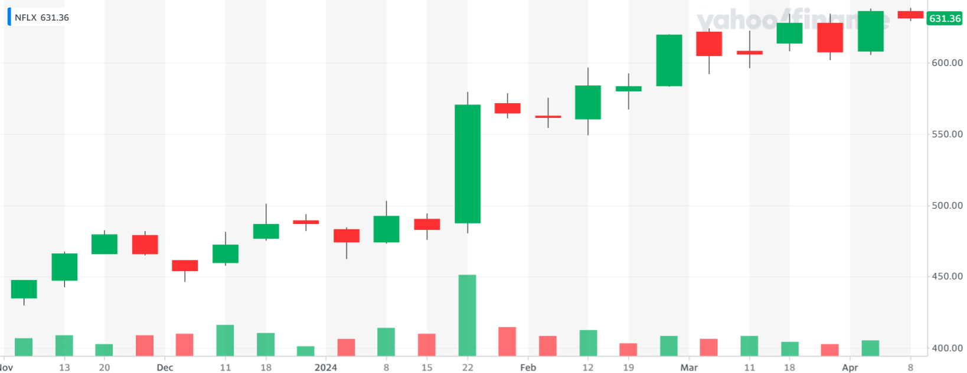

***Here is the Chart of Percentage Change in Stock Price of Netflix***

* **Volatility:**

**Netflix standard-deviation technical analysis lookup allows you to check this and other technical indicators for Netflix or any other equities. You can select from a set of available technical indicators by checking on the link to the right. Please note, not all equites are covered by this module due to inconsistencies in global equity categorization and data normalization techniques.**

**Netflix has current Standard Deviation of 1.97. The Standard Deviation is a measure of how spread out the prices or returns of assets are on average. It is the most widely used indicator in the field of investing and finance. Standard Deviation is commonly used to measure confidence in statistical conclusions regarding certain equity instruments or portfolios of equities.**

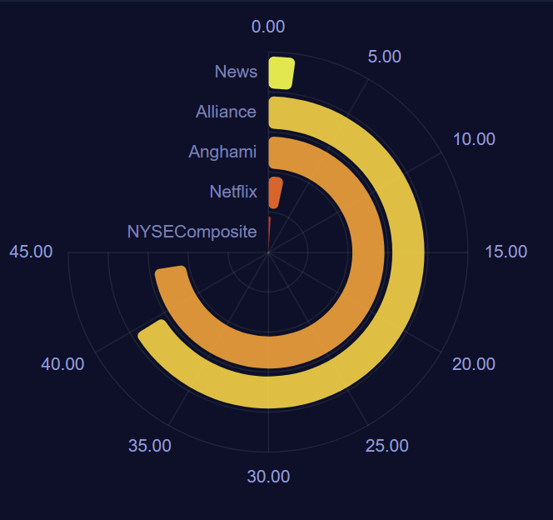

* **Average Trading Volume:**

**Analyzing the average trading value of Netflix can help investors gauge the liquidity of the stock and understand the level of market participation. Higher average trading values generally indicate more active trading and greater investor interest, while lower values may suggest reduced trading activity and potentially less liquidity in the market for Netflix shares.**

**Investors and analysts often use average trading value in conjunction with other metrics, such as price movements and trading volume trends, to assess the overall market sentiment and make informed decisions about buying, selling, or holding Netflix stock.**

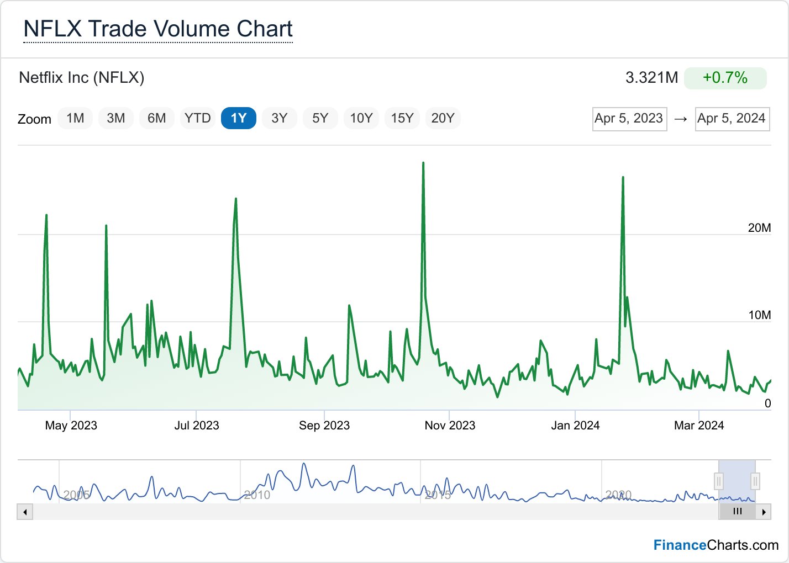

***Here is the Chart of Average Trade Volume***

**Compare Performance to Relevant Index**

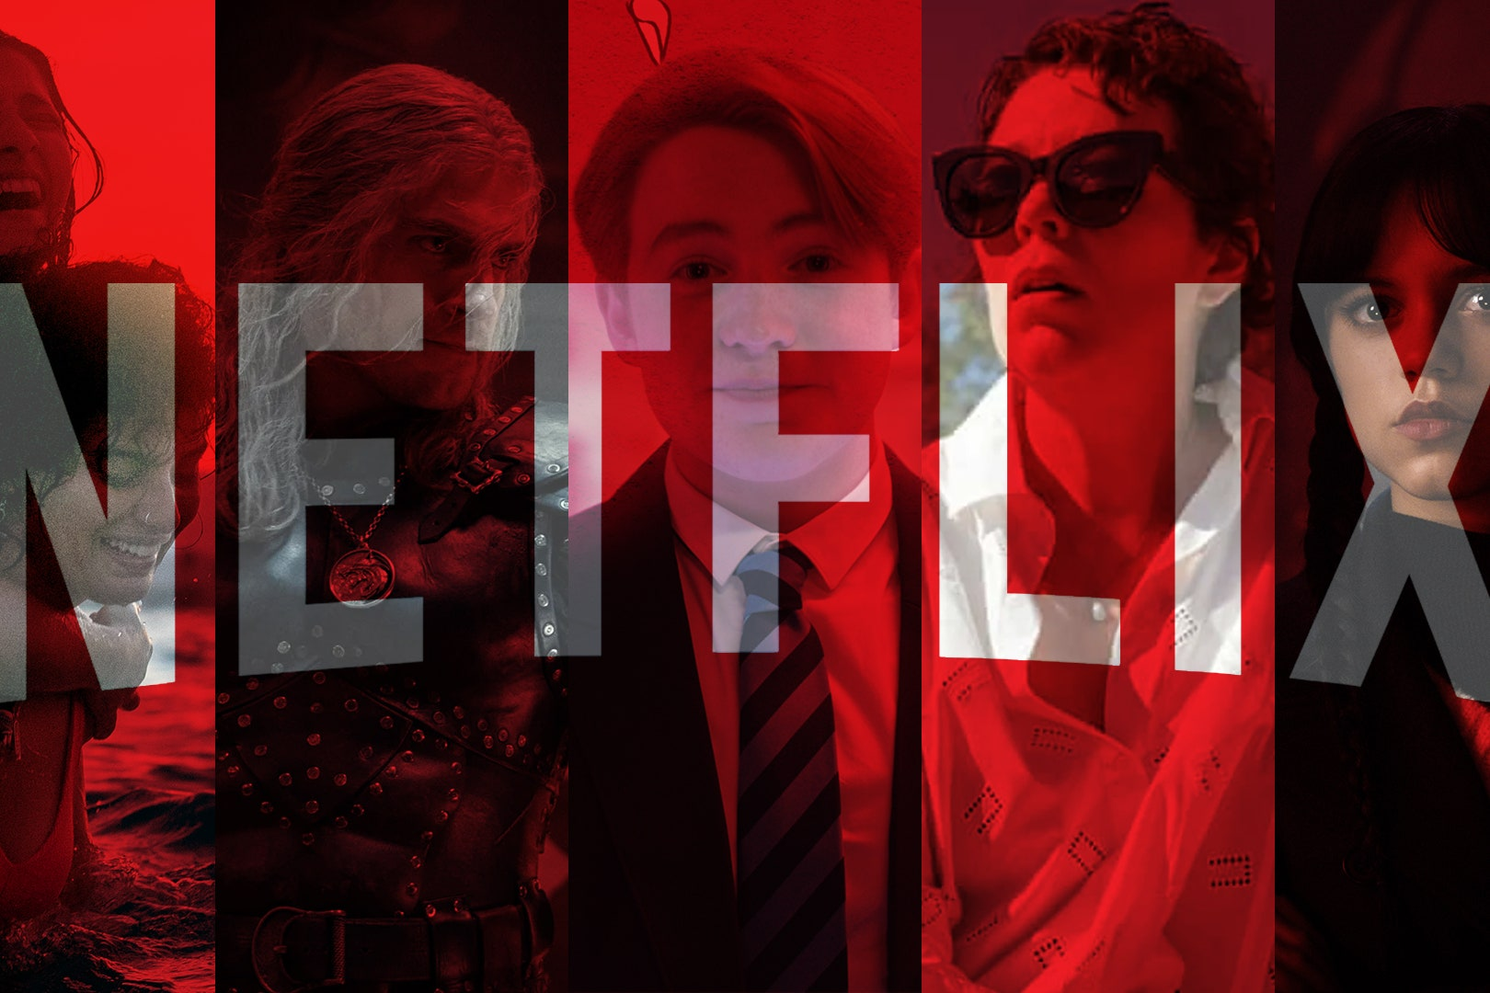

**Vs**



|  |  |
| --- | --- |
| **Netflix** | **Nifty50** |
| **1) We can look at metrics such as revenue growth, net income, and subscriber growth.** | **1) Since Nifty50 is an index comprising the top 50 companies listed on the National Stock Exchange of India, its performance is reflective of the overall Indian stock market.** |
| **2) We would examine its stock price movement over a given period, looking at factors such as stock price appreciation or depreciation.** | **2) This index tracks the performance of the top 50 companies in India, so its performance is indicative of the broader Indian stock market sentiment.** |
| **3) Netflix's volatility would be specific to its stock price movements.** | **3) while Nifty50's volatility would reflect market sentiment and macroeconomic factors affecting the Indian economy.** |
| **4) Risk factors for Netflix could include competition in the streaming industry, content acquisition costs, and regulatory challenges.** | **4) Risk factors could include geopolitical tensions, macroeconomic indicators, and policy changes affecting the Indian economy.** |
| **5) Investor sentiment towards Netflix would be influenced by factors such as new content releases, subscriber growth, and market penetration.** | **5) Nifty50's investor sentiment would be influenced by broader economic indicators, government policies, and global market trends.** |
| **6) Netflix typically does not pay dividends as it reinvests its earnings back into the business.** | **6) Nifty50 companies may pay dividends depending on their respective dividend policies.** |
| **7) Long-term performance can give insight into the sustainability and growth potential of both Netflix and Nifty50 companies.** | **7) Short-term performance can be influenced by various factors including quarterly earnings reports, economic data releases, and market sentiment.** |

**Founding and Early Years (1997-2006):**

1. **Netflix was founded in 1997 by Reed Hastings and Marc Randolph in Scotts Valley, California.**
2. **Initially, Netflix offered DVD rental by mail, disrupting the traditional video rental market dominated by Blockbuster.**
3. **In 2000, Netflix introduced a subscription model, allowing customers to rent unlimited DVDs for a monthly fee.**

**Streaming Revolution (2007-2013):**

1. **Netflix launched its streaming service in 2007, enabling subscribers to instantly watch TV shows and movies on their computers.**
2. **The company expanded its streaming service to gaming consoles, smart TVs, and mobile devices.**
3. **In 2010, Netflix began producing original content with the release of the series "House of Cards," marking a significant shift in its business model.**

**Global Expansion (2014-present):**

1. **Netflix expanded its streaming service globally, launching in various countries around the world, including Europe, Asia, and Latin America.**
2. **The company continued to invest heavily in original content, producing hit series such as "Stranger Things," "The Crown," and "Narcos."**
3. **In 2016, Netflix announced its first acquisition, purchasing Millar world, the comic book publishing company founded by Mark Millar.**
4. **In 2019, Netflix faced increased competition with the launch of other streaming services like Disney+ and Apple TV+.**

**Challenges and Innovations:**

1. **Netflix has faced challenges such as content licensing issues, increasing competition, and fluctuating subscriber growth.**
2. **The company has continued to innovate, experimenting with interactive content like "Black Mirror: Bandersnatch" and investing in diverse genres and international productions.**

**Covid 19 Pandemic (2020):**

1. **The COVID-19 pandemic led to a surge in demand for streaming services as people worldwide stayed indoors.**
2. **Netflix experienced a significant increase in subscribers during this period, with more people turning to streaming entertainment for solace and distraction.**

**Recent Developments:**

1. **Netflix has continued to expand its original content library, investing in a wide range of genres and formats.**
2. **The company faces challenges from new competitors, including streaming services from traditional media conglomerates like Disney, Warner Media, and NBCUniversal.**
3. **Netflix has been focusing on international growth and has been experimenting with different pricing strategies and content offerings to cater to diverse markets.**

***Conclusion:***

**Netflix remained one of the most dominant players in the streaming industry, boasting a vast library of content, including original series, movies, documentaries, and licensed shows. Netflix had established itself as a leader in the streaming market, with a significant subscriber base globally. Its original content strategy, coupled with an intuitive user interface and personalized recommendations, had helped it maintain its position against competitors.**

**Netflix had established itself as a leader in the streaming market, with a significant subscriber base globally. Its original content strategy, coupled with an intuitive user interface and personalized recommendations, had helped it maintain its position against competitors.**

**Netflix's investment in original content had been a key driver of its success. The platform had produced critically acclaimed series like "Stranger Things," "The Crown," and "House of Cards," along with successful films like "Bird Box" and "The Irishman." This focus on original content had enabled Netflix to differentiate itself and attract subscribers.**

**Netflix had aggressively expanded its presence worldwide, making its service available in numerous countries and regions. However, it faced challenges in certain markets due to competition, regulatory issues, and differing consumer preferences.**

**Netflix had aggressively expanded its presence worldwide, making its service available in numerous countries and regions. However, it faced challenges in certain markets due to competition, regulatory issues, and differing consumer preferences.**

**Despite its dominance, Netflix faced increasing competition from other streaming services such as Disney+, Amazon Prime Video, HBO Max, and Apple TV+. These competitors had been investing heavily in their own original content and expanding their libraries, posing a threat to Netflix's market share.**

***Thank You***

***By Sahil Arjee***

***Registration No.: 121128807080***

***BBA 3rd Year***

***Dr. Lankapalli Bullaya College Visakhapatnam***